SWECC004 — Leaf nutrient analysis
MP-AES multi-element analysis of Quercus robur leaf digests
Natuurbegraafplaats Huis ter Heide, De Moer (Zeist) — seven oaks
Nālani Balcells · Avans University of Applied Sciences · June 2026

1. Purpose and methods
This document reports the multi-element analysis of oak leaf digests carried out by microwave plasma atomic emission spectrometry (MP-AES). The aim is to quantify the nutritional status of each study tree on the eight elements most relevant to oak vitality — potassium, magnesium, zinc, aluminium, manganese, copper, iron and calcium — and to interpret the resulting profile against the literature critical-value ranges for Quercus robur. The dataset has been re-analysed from raw Agilent MP-AES intensities using an inverse two-line calibration model (concentration as the outcome, both emission lines as predictors) per element, which uses all available spectral information jointly and remains robust to small inter-line interferences. Two technical replicates per tree (.1 and .2 digestions) are averaged to a single per-tree value, giving n = 1 per tree.
The seven trees are FT01, FT02 and FT03 (bokashi-treated since 2022), NFT04, NFT05 and NFT06 (untreated reference of similar age in the same compartment) and HT07 (visually healthy reference tree). Calibration standards are a blank plus six concentration points (0.1, 0.5, 1.0, 5.0, 10.0 and 50.0 mg L⁻¹), matrix-matched to the digested sample acidity (≈ 3.9 % HNO₃).

2. Calibration
The two-line inverse calibration reproduces the standard concentrations with essentially no in-sample error (Figure 1): the predicted values fall on the 1:1 line for K, Mg, Zn, Al, Mn, Cu, Fe and Ca alike, indicating that the model captures the standard intensities well. Because in-sample R² of a two-predictor / seven-point fit is by construction optimistic, leave-one-out cross-validation is reported alongside as the honest measure of predictive accuracy (Figure 2). Cross-validated RMSE is below 1 ppm for six of the eight elements (Cu 0.21, Mn 0.53, Mg 0.99, Zn 0.42, Fe 0.69, K 0.47 ppm) and remains under 1.2 ppm for the remaining two (Al 1.17, Ca 0.50 ppm). On the basis of these calibration statistics K, Mg, Zn, Al, Mn and Cu are reported as quantitatively reliable; Fe and Ca are flagged separately as untrustworthy in the sample data because their sample-side readings fall outside the calibrated range (Ca over-range, Fe below detection in the digests despite a well-fit calibration curve).
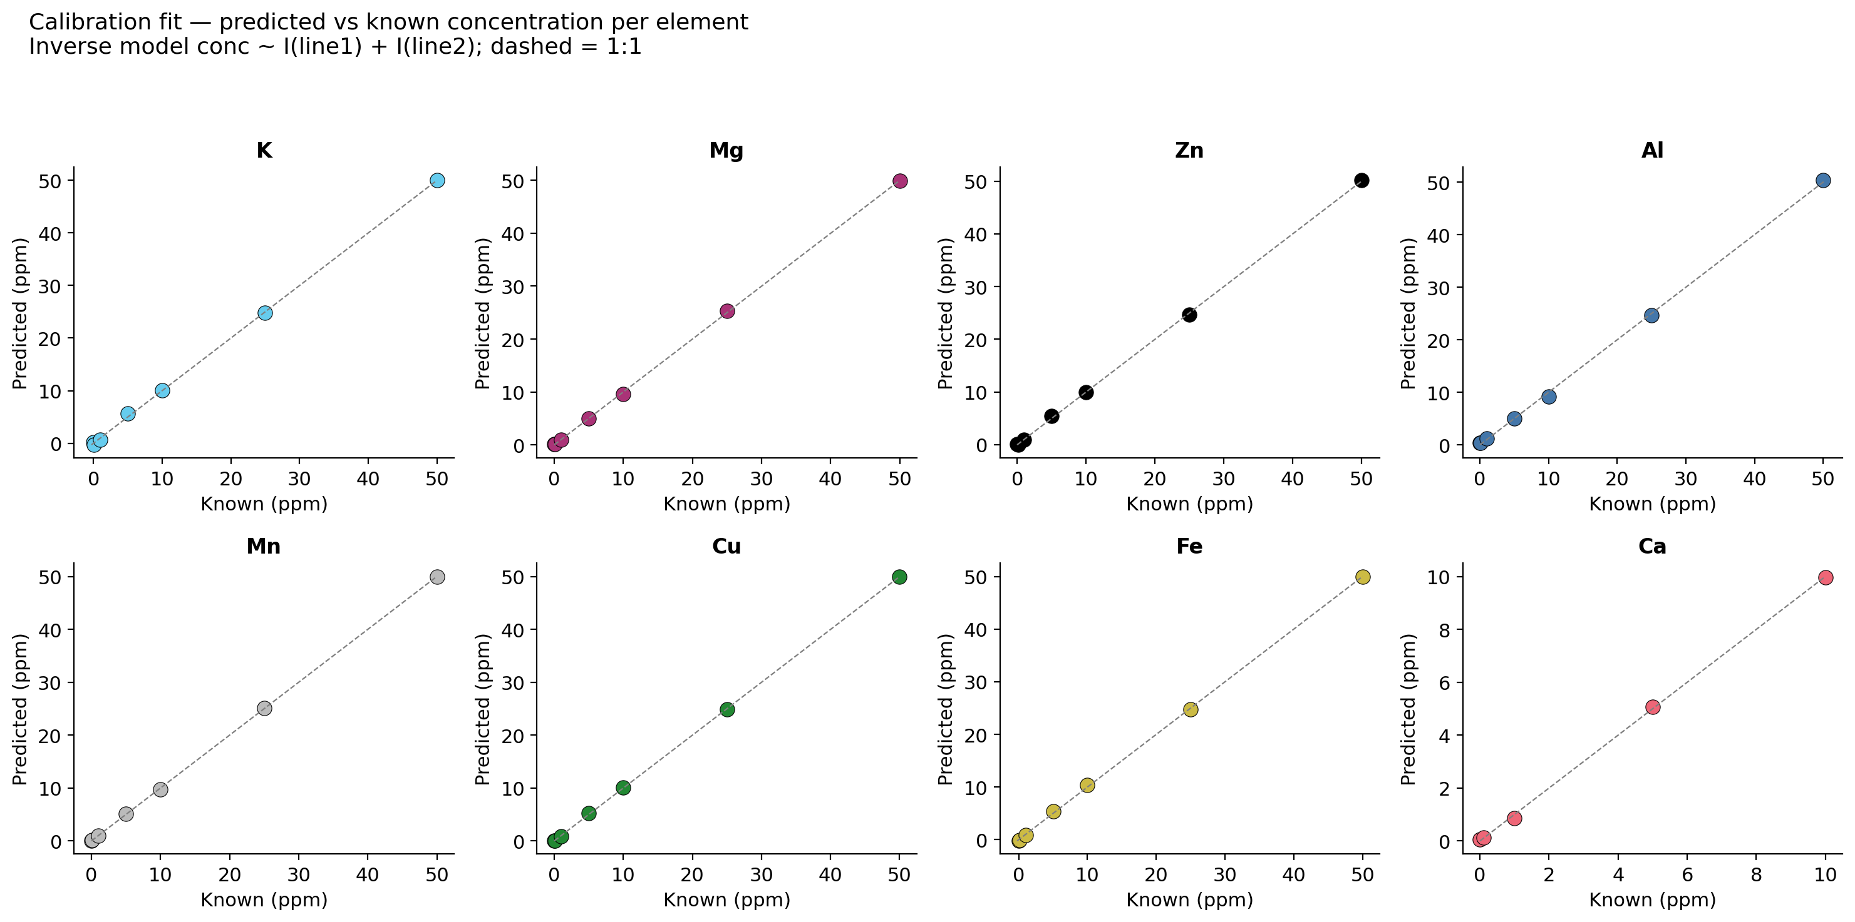
Figure 1. Calibration fit per element. Predicted concentration from the inverse two-line model plotted against the known standard concentration. Dashed line is the 1:1 reference.
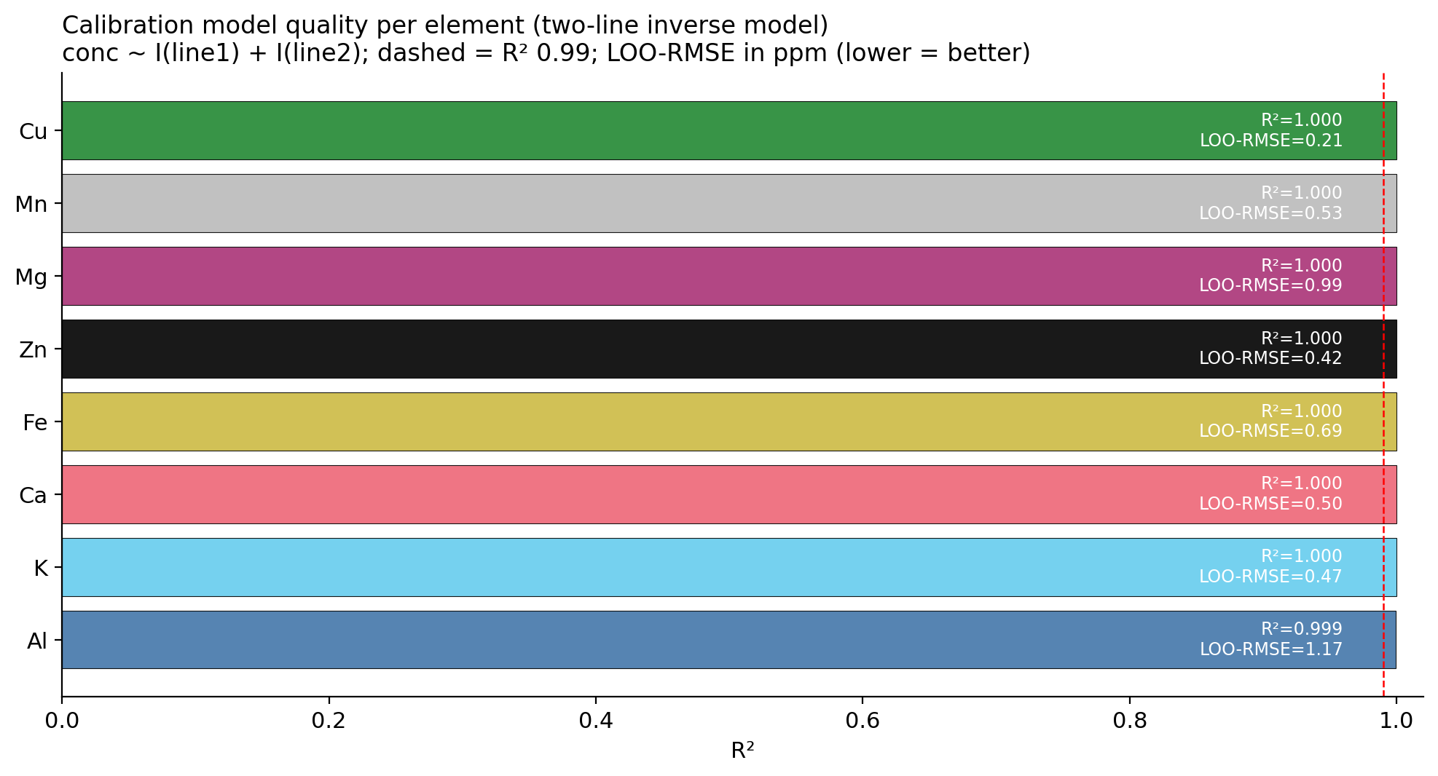
Figure 2. Calibration model quality per element. R² and leave-one-out RMSE (in ppm) for the two-line inverse model. Dashed red line marks R² = 0.99.

3. Leaf concentrations per tree and per treatment
The reliable elements show three consistent treatment-level patterns (Figure 3). First, the bokashi group has higher leaf potassium and magnesium than the untreated group on every tree pair: bokashi means are 46.1 ppm K and 7.6 ppm Mg, against 33.2 ppm K and 5.2 ppm Mg in the untreated group, and 44.7 K / 5.0 Mg in the healthy reference. The K signal is stronger and more consistent than the Mg signal but both are in the expected direction for an organic-matter amendment that supplies cations to the cation-exchange complex. Second, zinc shows the most dramatic separation of any element: every bokashi replicate registers between roughly 10 and 60 ppm Zn in the digest while every untreated replicate sits near zero — a categorical rather than gradient difference. This is consistent with a soil pH and organic-matter complexation effect, since bulk soil Zn differs only marginally between the two groups (the soil-side MP-AES result is reported in the Soil analysis folder); under bokashi the available fraction is mobilised. Third, manganese and aluminium move in the opposite direction: untreated trees have higher leaf Mn (mean 0.51 ppm vs 0.09 bokashi) and substantially higher leaf Al (mean +0.39 vs −0.55 bokashi). Both elements are characteristic acid-stress micronutrients and the bokashi-led reduction is the strongest evidence on the leaf side that bokashi tempers acid-stress uptake.
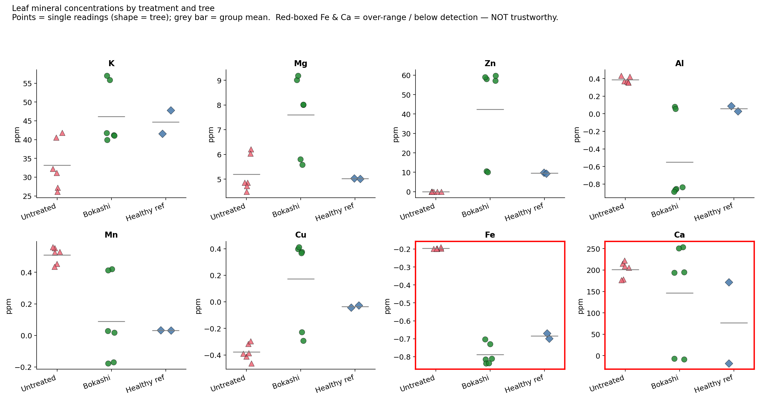
Figure 3. Leaf mineral concentrations by treatment and tree. Each point is one .1 or .2 reading; shape encodes the tree, colour encodes the treatment. Grey horizontal bar = group mean. Red-boxed Fe and Ca panels are flagged as untrustworthy because Ca exceeds the calibration range in the leaf digests and Fe falls below detection.
Copper shows a smaller but consistent positive bokashi effect (mean +0.17 ppm under bokashi against −0.37 untreated). Leaf Ca and Fe are not interpretable from this campaign — Ca exceeded the upper calibration standard at 50 mg L⁻¹ for several samples and Fe came in at intensity values below the blank for every untreated tree. The recommended remedy for the next sampling round is to remake the Ca calibration up to at least 200 mg L⁻¹ and to use a higher pre-analysis dilution factor for Ca specifically, while keeping the dilution factor on the other elements unchanged.

4. Multivariate picture (PCA)
Principal-component analysis on the five reliable elements (K, Mg, Zn, Al, Mn), standardised so that K does not dominate by scale, projects the seven trees onto a two-axis space in which PC1 explains 84.0 % of the between-tree variance and PC2 explains a further 10.3 % (Figure 4). The first axis is dominated by the K, Mg and Zn loadings on one end and the Al and Mn loadings on the other; it therefore reads directly as a bokashi-versus-untreated direction. The three bokashi trees (T1, T2, T3) sit on the left, the three untreated trees (T4, T5, T6) on the right, and the healthy reference HT07 sits inside the bokashi cluster — which confirms that on the multivariate mineral profile the healthy reference tree resembles the bokashi-treated trees more closely than the untreated trees, and that two applications of bokashi have moved the treated trees substantially in the direction of the healthy reference even though the absolute group means have not yet converged.
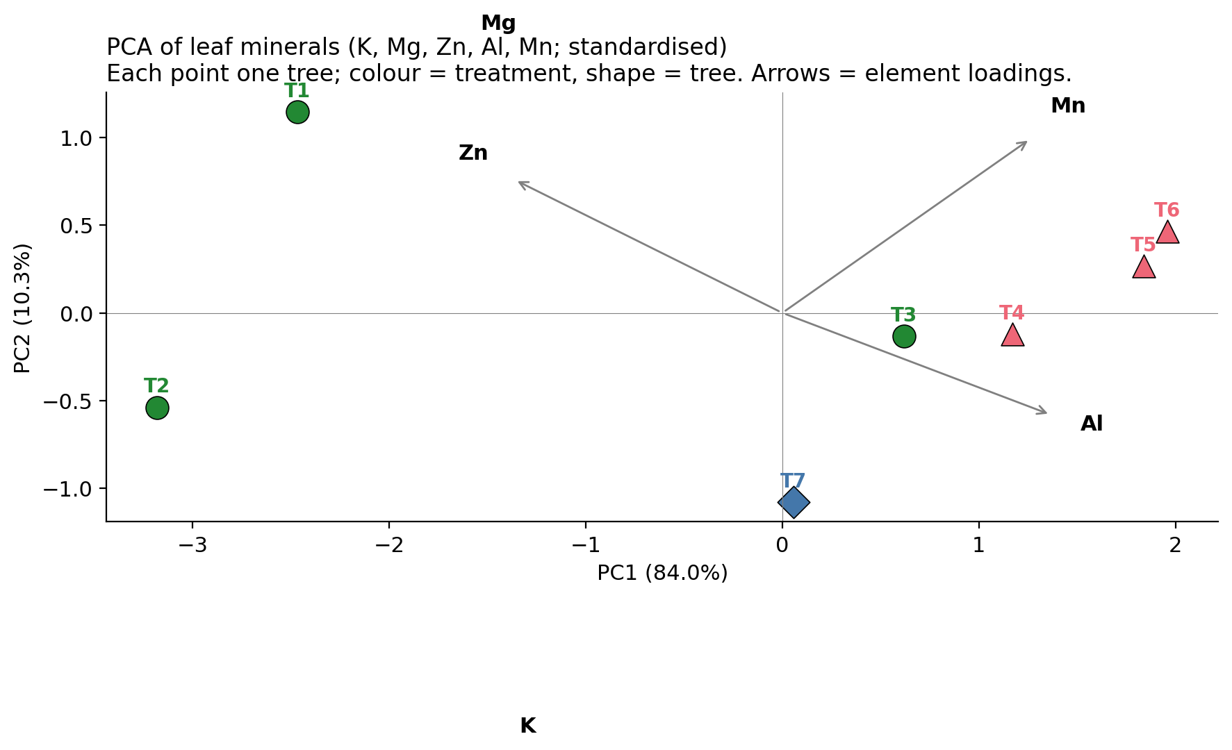
Figure 4. PCA of leaf minerals (K, Mg, Zn, Al, Mn; standardised correlation PCA). Each point is one tree; colour = treatment, shape = tree. Arrows are element loadings on PC1 and PC2.

5. Conclusions

5.1 Leaf nutrient status
The leaf nutrient profile of the bokashi-treated trees is more favourable than that of the untreated trees on every reliable element: higher K, Mg, Zn and Cu, lower Mn and Al. The size of the differences is largest on Zn (categorical) and clearest on the multivariate PCA, where bokashi trees and the healthy reference cluster together on the left of PC1 while untreated trees occupy the right. The healthy reference tree is not the upper outlier on every individual element — bokashi trees match or exceed it on K, Mg and Zn — but it sits inside the bokashi cluster in the multivariate space, which is the expected position for a tree that was selected on visual criteria rather than on lab values.

5.2 Calibration recommendation
Two elements (Ca and Fe) are not interpretable in this campaign. The next sampling round should remake the Ca standards up to 200 mg L⁻¹ and increase the pre-analysis sample dilution by a factor of approximately five for Ca only, leaving the other six elements at the current dilution. With a correctly scaled Ca calibration the full eight-element profile becomes available for interpretation, and leaf Ca becomes one of the more informative literature-reference points for Quercus robur on acid podzols.

5.3 Statistical limit
With three trees per treatment and one healthy reference, the data are sufficient to describe direction of effect but not magnitude with confidence. The PCA result and the within-pair consistency on K, Mg and Zn are nevertheless robust enough that the qualitative picture (bokashi > untreated on macronutrients and micronutrients; bokashi < untreated on acid-stress micronutrients) can be reported as a working conclusion. Formal significance testing is deferred to the larger study described in the monitoring plan.

Files in this folder
SWECC04_analysis.R — full reproducible R script for the inverse calibration, sample prediction, descriptive statistics and PCA.
SWECC04.csv — raw Agilent MP-AES export (blank + six standards + sample duplicates, eight elements at two emission lines each).
leaf_per_tree.csv — long-form per-tree mean concentrations from the R analysis.
leaf_per_tree_concentrations.csv — wide-form per-tree mean concentrations (rows = trees, columns = elements) for downstream use.
leaf_fig1_calibration_fit.png … leaf_fig4_pca.png — the four figures reproduced in this document.
SWECC004_leaf_nutrient_description.docx — this document.

